Construction of a Spatial Depopulation Risk Index in municipalities of Castilla-La Mancha

HIDALGO ARELLANO, ISIDRO; FERNÁNDEZ-AVILÉS CALDERÓN, GEMA

Universidad de Castilla-La Mancha

Isidro.Hidalgo@uclm.es

Depopulation in Castilla-La Mancha has become a significant problem: vast extensions of Cuenca and Guadalajara have less population density than Siberia. Governments of some countries and region authorities have elaborated classifications for the depopulation risk of villages and towns. For example, the Government of Castilla-La Mancha use descriptive statistics taking into account social and economic variables to classify areas from “urban” to “zones with extreme risk of depopulation”.

The main aim of this work is the construction of a Spatial Depopulation Risk Index for the 919 municipalities of Castilla-La Mancha, using geostatistic techniques and principal component analysis. The theoretical semivariogram reveals spatial dependence up to a distance of 60 kilometers. Taking in account the range of spatial dependence, a neighborhood network is constructed. Then a spatial principal component analysis (sPCA) [1] is performed over a set of demographic variables. Finally, the spatial depopulation risk index (sDRI) is designed extracting and scaling the first sPCA principal component.

As can be seen from next figure, the resulting sDRI marks as zones with medium to high risk of depopulation the majority of villages of Cuenca and Guadalajara, the East and the South of the region, leaving without risk the zones of La Mancha and the Sagra and Henares industrial corridors, as well as the province capitals, Talavera de la Reina and Puertollano:

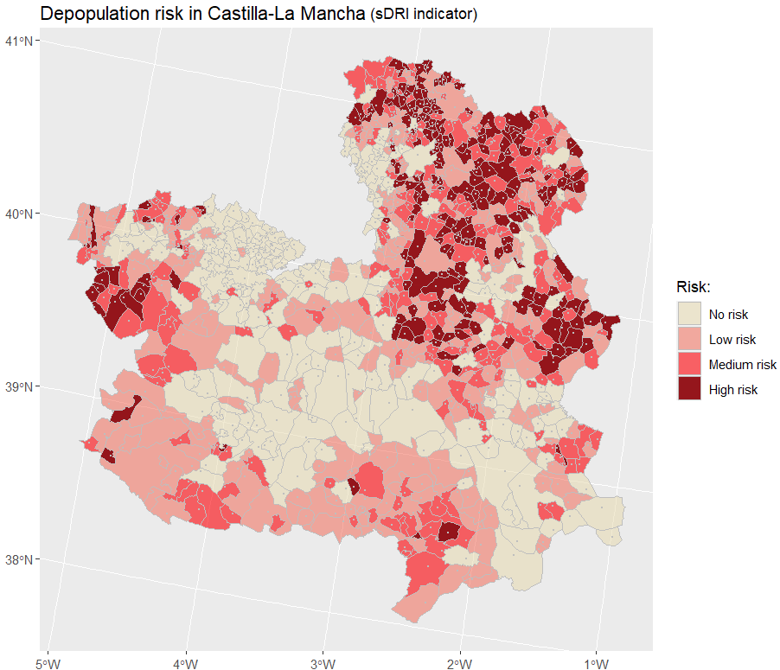

Referencias

1. Jombart, T.; Devillard, S.; Dufour, A.-B.; Pontier, D. *Revealing cryptic spatial patterns in genetic variability by a new multivariate method*, Heredity, 101 (2008), 92-103.